
OPC Unified Architecture
Draft Specification
Part 9: Alarms
Draft Version 0.62
Mar 26, 2006
Send comments to:
UAcomments@opcfoundation.org

Specification Type | Industry Standard Specification
Title: | OPC Unified Architecture  Alarms | Date: | Mar 26, 2006
Version: | Draft Specification 0.62 | Software | MS-Word
 |  | Source: | 0000.doc
Author: | OPC Foundation | Status: | Draft Specification

CONTENTS
Page

FOREWORD 6
INTRODUCTION 7
1 Scope 8
2 Reference documents 8
3 Terms, definitions, and abbreviations 8
3.1 OPC UA Part 1 terms 8
3.2 OPC UA Part 3 terms 8
3.3 Abbreviations and symbols 9
4 Concepts 9
4.1 General 9
5 Information Model 10
5.1 General 10
5.2 Sub Condition model 10
5.2.1 Overview 10
5.2.2 Standard Sub Condition types 11
5.3 Condition Event Type 11
5.3.1 Overview 11
5.3.2 Enabled 12
5.3.3 Active 12
5.3.4 ActiveTime 13
5.3.5 InactiveTime 13
5.3.6 Unacknowledged 13
5.3.7 Sub condition 13
5.3.8 Condition State 13
5.4 Process Conditions 15
5.4.1 Process Condition 15
5.4.2 Level Alarm 16
5.4.3 Deviation Alarm 16
5.4.4 Rate Alarm 16
5.4.5 Change of State Alarm 16
5.4.6 Trip Alarm 16
5.5 Maintenance Conditions 16
5.5.1 Equipment Service Warning 16
5.5.2 Equipment Failure Alarm 16
5.6 System Conditions 17
5.6.1 System Warning 17
5.6.2 System Fault Alarm 17
5.6.3 Safety Fault Alarm 17
6 Services 17
6.1 Read 17
6.2 Historical Read 17
6.3 Condition Subscriptions 17
6.3.1 Refresh 17
6.4 Acknowledge 17

Figures
Figure 1 – Condition Types 10
Figure 2 – Condition State Diagram 14

Tables
Table 1 – Sub Condition Type Definition 11
Table 2 – Standard Sub conditions 11
Table 3 – Condition Event Type Definition 12
Table 4 – Process Condition Type Definition 15
Table 5 – Level Alarm Type Definition 16
Table 6 – Acknowledge Request 18
Table 7 – Acknowledge Response 18

OPC Foundation
____________

UNIFIED ARCHITECTURE –
FOREWORD
This specification is the specification for developers of OPC UA clients and servers. The specification is a result of an analysis and design process to develop a standard interface to facilitate the development of servers and clients by multiple vendors that shall inter-operate seamlessly together.
Trademarks
Most computer and software brand names have trademarks or registered trademarks. The individual trademarks have not been listed here.
NON-EXCLUSIVE LICENSE AGREEMENT
The OPC Foundation, a non-profit corporation (the “OPC Foundation”), has defined a set of standard objects, interfaces and behaviors associated with the objects intended to promote interoperability between automation/control applications, field systems/devices, and business/office applications in the process control industry.
The OPC specifications, sample software (that demonstrates the implementation of the specifications, standard interface components deliverables and related documentation (collectively, the “OPC Materials”), form a set of standard objects, interfaces and behavior that are based on the technology being used in the automation marketplace, and includes the use of Microsoft Technology as well providing interoperability to non Microsoft platforms. The technology defines standard objects, methods, and properties for servers of real-time information like distributed process systems, programmable logic controllers, smart field devices and analyzers in order to communicate the information that such servers contain to standard compliant technologies enabled devices (e.g., servers, applications, etc.).
The OPC Foundation will grant to you (the “User”), whether an individual or legal entity, a license to use, and provide User with a copy of, the current version of the OPC Materials so long as User abides by the terms contained in this Non-Exclusive License Agreement (“Agreement”). If User does not agree to the terms and conditions contained in this Agreement, the OPC Materials may not be used, and all copies (in all formats) of such materials in User’s possession must either be destroyed or returned to the OPC Foundation. By using the OPC Materials, User (including any employees and agents of User) agrees to be bound by the terms of this Agreement.
LICENSE GRANT:
Subject to the terms and conditions of this Agreement, the OPC Foundation hereby grants to User a non-exclusive, royalty-free, limited license to use, copy, display and distribute the OPC Materials in order to make, use, sell or otherwise distribute any products and/or product literature that are compliant with the standards included in the OPC Materials.
All copies of the OPC Materials made and/or distributed by User must include all copyright and other proprietary rights notices include on or in the copy of such materials provided to User by the OPC Foundation.
The OPC Foundation shall retain all right, title and interest (including, without limitation, the copyrights) in the OPC Materials, subject to the limited license granted to User under this Agreement.
WARRANTY AND LIABILITY DISCLAIMERS:
User acknowledges that the OPC Foundation has provided the OPC Materials for informational purposes only in order to help User understand Microsoft’s OLE/COM technology. THE OPC MATERIALS ARE PROVIDED “AS IS” WITHOUT WARRANTY OF ANY KIND, EXPRESS OR IMPLIED, INCLUDING, BUT NOT LIMITED TO, WARRANTIES OF PERFORMANCE, MERCHANTABILITY, FITNESS FOR A PARTICULAR PURPOSE OR NON-INFRINGEMENT. USER BEARS ALL RISK RELATING TO QUALITY, DESIGN, USE AND PERFORMANCE OF THE OPC MATERIALS. The OPC Foundation and its members do not warrant that the OPC Materials, their design or their use will meet User’s requirements, operate without interruption or be error free.
IN NO EVENT SHALL THE OPC FOUNDATION, ITS MEMBERS, OR ANY THIRD PARTY BE LIABLE FOR ANY COSTS, EXPENSES, LOSSES, DAMAGES (INCLUDING, BUT NOT LIMITED TO, DIRECT, INDIRECT, CONSEQUENTIAL, INCIDENTAL, SPECIAL OR PUNITIVE DAMAGES) OR INJURIES INCURRED BY USER OR ANY THIRD PARTY AS A RESULT OF THIS AGREEMENT OR ANY USE OF THE OPC MATERIALS.
GENERAL PROVISIONS:
This Agreement and User’s license to the OPC Materials shall be terminated (a) by User ceasing all use of the OPC Materials, (b) by User obtaining a superseding version of the OPC Materials, or (c) by the OPC Foundation, at its option, if User commits a material breach hereof. Upon any termination of this Agreement, User shall immediately cease all use of the OPC Materials, destroy all copies thereof then in its possession and take such other actions as the OPC Foundation may reasonably request to ensure that no copies of the OPC Materials licensed under this Agreement remain in its possession.
User shall not export or re-export the OPC Materials or any product produced directly by the use thereof to any person or destination that is not authorized to receive them under the export control laws and regulations of the United States.
The Software and Documentation are provided with Restricted Rights. Use, duplication or disclosure by the U.S. government is subject to restrictions as set forth in (a) this Agreement pursuant to DFARs 227.7202-3(a); (b) subparagraph (c)(1)(i) of the Rights in Technical Data and Computer Software clause at DFARs 252.227-7013; or (c) the Commercial Computer Software Restricted Rights clause at FAR 52.227-19 subdivision (c)(1) and (2), as applicable. Contractor / manufacturer are the OPC Foundation,. 16101 N. 82nd Street, Suite 3B, Scottsdale, AZ, 85260-1830
Should any provision of this Agreement be held to be void, invalid, unenforceable or illegal by a court, the validity and enforceability of the other provisions shall not be affected thereby.
This Agreement shall be governed by and construed under the laws of the State of Minnesota, excluding its choice or law rules.
This Agreement embodies the entire understanding between the parties with respect to, and supersedes any prior understanding or agreement (oral or written) relating to, the OPC Materials.
INTRODUCTION
This specification defines the alarming model that extends the base event model for OPC Unified Architecture (UA) servers.
Scope
This specification specifies the representation of alarms in the OPC Unified Architecture. Included is the specification of the representation of alarms in the OPC UA address space, the definition of alarm notification formats, and the definition of filters used in alarm subscriptions.

Reference documents
It is assumed that the reader is familiar with Web Services, and XML/SOAP. Information on these technologies can be found at the W3C web sites.

Terms, definitions, and abbreviations

OPC UA Part 1 terms
The following terms defined in Part 1 of this multi-part specification apply.
- address space
- complex data
- information model
- message
- node
- node hierarchy
- node type
- notification
- notification message
- object
- object type
- property
- property type
- reference
- reference type
- root node
- server type
- source node
- subscription
- view

OPC UA Part 3 terms
The following terms defined in Part 3 of this multi-part specification apply.
- branch node
- cardinality
- leaf node
- node attribute
- target node

Abbreviations and symbols
A&E Alarms and Events
API Application Programming Interface
COM Component Object Model
DA Data Access
DCOM Distributed COM
DX Data Exchange
HDA Historical Data Access
PLC Programmable Logic Controller
SOAP Simple Object Access Protocol
UA Unified Architecture
UML Unified Modelling Language
WSDL Web Services Definition Language
XML Extensible Mark-up Language

Concepts

General
This specification extends general eventing by defining an alarm model. The Alarm model provides the core behavior expected to support control system alarm management functionality. It is however not limited to control systems and can be extended to support the needs of other domains.
Alarms are defined as extensions of the basic event model. Alarms represent conditions of a system or one of its components. For example, a device or block may have a “LevelAlarm” and a “DeviationAlarm” condition associated with it.
Furthermore, a condition may be defined to include multiple sub-conditions. For example, a LevelAlarm condition may include the “HighAlarm”, “HighHighAlarm”, “LowAlarm”, and “LowLowAlarm” sub-conditions.

Information Model

General
The alarm model extends the event model by defining condition events. This event type can be further extended to form domain or server specific condition types. The condition type introduces the concept of state to form the alarming model differentiating it from the basic event model. Unlike the other event types conditions are not transient.
Alarms are represented by Conditions in UA. Conditions may be optionally exposed in the address space in order to allow direct access to the state of conditions.

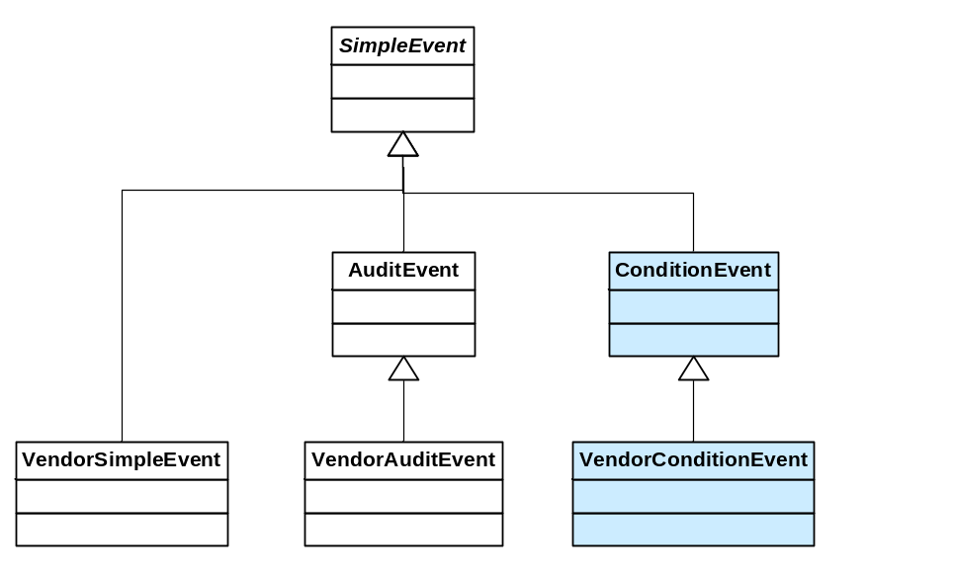
Figure 1 – Condition Types

Sub Condition model

Overview
Sub conditions make up part of the overall state of a condition. For example a level alarm condition can be in a normal condition, a high alarm condition, etc. These states of a condition are referred to as sub conditions of the condition.
Sub conditions are exposed in the server’s address space as an array of Sub Condition types. Sub condition types are always abstract and are only use by a condition to describe its present sub condition state.

Table 1 – Sub Condition Type Definition
Attribute | Value
browse name | Sub Condition Type
node identifier | 9000
Is abstract | True
References |  | Node Class | Browse Name | Data Type | Node Id | Instance Definition | Type Definition | Instantiation Rule
has property |  | variable | Definition | String |  | - |  | new

The Definition variable provides the detailed definition of what is used to establish the sub condition. For example a high limit sub condition could be defined as being “measured value exceeds high limit value”.

Standard Sub Condition types
Standard sub conditions are defined in Table 2 below. Servers may use this standard set and may define server specific sub condition types.
Table 2 – Standard Sub conditions
Condition Type | Sub Condition | ID | Description
Level Alarm | Low |  | A Low level alarm
 | High |  | A High level alarm
 | Low Low |  | A very Low level alarm
 | High High |  | A very High level alarm
 | Normal |  | No Level alarm present
Deviation Alarm | Low |  | A Low deviation from set point alarm
 | High |  | A High deviation from set point alarm
 | Normal |  | No deviation alarm present
Rate Alarm | High |  | A High rate of change alarm
 | High High |  | A very high rate of change alarm
 | Normal |  | No rate alarm present
Change of State | Active |  | The signal has transitioned to the active state
 | Inactive |  | The signal has transitioned to the inactive state
State Alarm | Active |  | The State alarm is active
 | Normal |  | No State alarm present

Condition Event Type

Overview
Conditions are specializations of events and therefore share the event model described in [part 3], [part 4] and [part 5].
Conditions are not just transient they exist in an active or inactive state. They can be enabled and disabled and acknowledged. In addition to generating event notifications like other event types instances of conditions may exist in the address space. An instance of a condition type allows clients to subscribe directly to them.

Table 3 – Condition Event Type Definition
Attribute | Value
browse name | Condition Event Type
node identifier | 9001
is abstract | False
References |  | Node Class | Browse Name | Data Type | Node Id | Instance Definition | Type Definition | Instantiation Rule
has property |  | variable | Event Id | GUID | 2283 | - |  | new
has property |  | variable | Event Type | NodeId | 2284 | - |  | new
has property |  | variable | Source Node | NodeId | 2285 | - |  | new
has property |  | variable | Source Name | QName | 2286 | - |  | new
has property |  | variable | Time | UtcTime | 2287 | - |  | new
has property |  | variable | Description | Localized Text | 2288 | - |  | new
has property |  | variable | Severity | UInt16 | 2289 | - |  | new
has property |  | variable | Enabled | Boolean |  | - |  | new
has property |  | variable | Active | Boolean |  | - |  | new
has property |  | variable | ActiveTime | UtcTime |  | - |  | new
has property |  | variable | InactiveTime | UtcTime |  | - |  | new
has property |  | variable | Unacknowledged | Boolean |  | - |  | new
Has property |  | variable | AckTime | UtcTime
Has property |  | variable | AuditEntryID | String
Has property |  | variable | Comment | Localized Text
Has property |  | variable | Sub Condition | NodeId

This condition event type inherits all properties of the base event type. Their semantic is defined in [part 5].

Enabled
Clients may enable and disable conditions, and the resulting behaviour is illustrated in Figure 2. Additional behaviours are noted below:
- The server may choose to continue to test for a condition while it is disabled. However, no event notifications will be generated while the condition is disabled, nor can it be acknowledged while it is disabled.
- It is server-specific as to whether or not the following condition properties are defined while in the disabled state: Active, ActiveSubCondition, Quality, Acked, LastAckTime, SubCondLastActive, CondLastActive, LastInactive, AcknowledgerID, and Comment.
- On a refresh, no event notifications will be generated for disabled conditions.
- When enabled, the Time attribute associated with the “Condition Active” event notification will either be the time the condition is first discovered after enabling, or the time it became active (server-specific).

Active
The value provides indicates if the current sub-conditions is considered an active condition. For example a level alarm with a sub-condition of High is considered active and therefore the value of this condition would be true. If however the sub-condition changed to normal then the value would be false.

ActiveTime
The time of the last transition into the active state. This is used to correlate condition acknowledgements with a particular transition into the sub-condition.

InactiveTime
The time of the last transition into the inactive state. This is used to correlate condition acknowledgements with a particular transition into the sub-condition.

Unacknowledged
Unacknowledged indicates the current acknowledgement state of the condition. The server determines when a condition state change requires an acknowledgement. Normally this would be when a condition transitions from the inactive to an active state however this is not always true nor is it the only case that can set the unacknowledged indicator.
ackTime – The time of the last acknowledgement of this condition. If the condition has not been acknowledged the time is null.
AuditEntryID – The audit entry ID provided with the last acknowledge of this condition. If the condition has not been acknowledged the entry will be null.
Comment – The optional comment supplied by with last acknowledgement of the condition. It will be null if not supplied or if the condition is not been acknowledged.

Sub condition
Sub Condition indicates the current state of the condition. The Active variable provides a Boolean indication of the conditions overall state. Sub conditions further define the state of the condition. The variable references one of the servers defined sub conditions see section 4.2.2 for a list of common sub conditions.

Condition State
A Condition’s state is defined by the combination of several properties of the condition. The state diagram below illustrates a typical server’s handling of a condition.
Figure 2 shows a state machine for Condition which requires acknowledgement. Note that the intent of this diagram is to convey the expected behaviour of conditions, as viewed by a client of the Server. It is not intended to specify implementation, other than that the implementation must support the expected behaviour.
Each state transition is a Condition event. Condition Event notification messages are sent at each state transition.
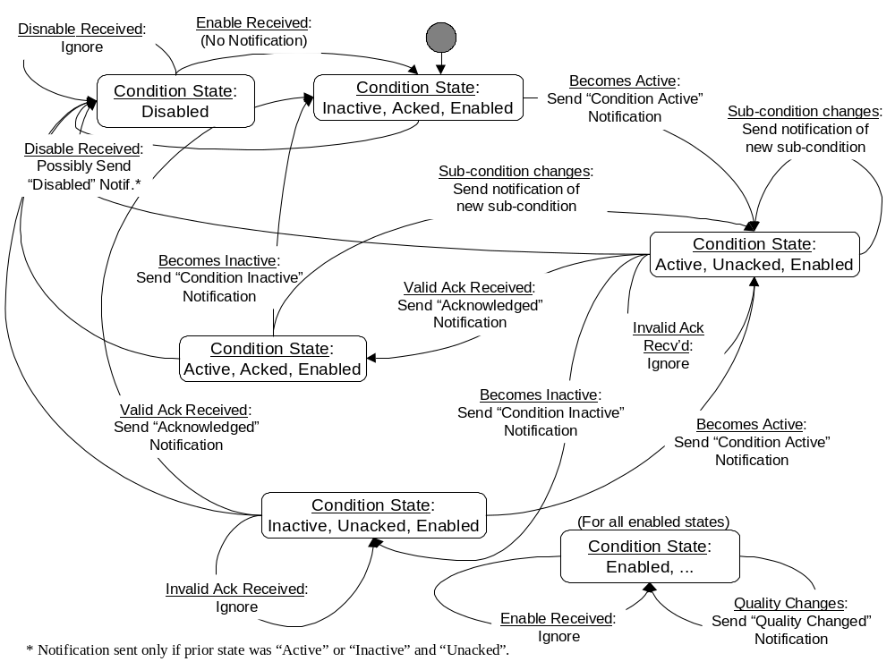
Figure 2 – Condition State Diagram
Every condition event notification which requires acknowledgment includes the Name of the condition, the time that the condition most recently entered the active state or transitioned into a new sub-condition, and the sequence number which uniquely identifies the event notification. This information is provided back to the server by a Client when acknowledging the condition. This information is used by the Server to identify which specific event occurrence (state transition) is being acknowledged. If an acknowledgment is received with out-of-date information (this can occur due to latency in the system), the condition state does not become acknowledged.
Note that an acknowledgement affects the condition state only if it (the condition) is currently active or it is currently inactive and the most recent active condition was unacknowledged. If an inactive, unacknowledged condition again becomes active, all subsequent acknowledgements will be validated against the newly active condition state attributes. The server may optionally use the sequence number of the Notification to log acknowledgement of “old” condition activations, but such “late” acknowledgements have no affect on the current state of the condition.
Acknowledgment of the condition active state may come from the client or may be due to some logic internal to the Server. For example, acknowledgment of a related Condition may result in this Condition becoming acknowledged, or the Condition may be set up to automatically acknowledge itself when the condition becomes inactive.
For conditions that do not track or require acknowledgement, the state transitions are simpler - just between enabled inactive, enabled-active, and disabled states.
Enabling a condition places it in the inactive-acked-enabled state. It is possible for the condition to become active very quickly after being enabled. No special scan/calculation are performed as part of the enabling action.
The server will generate audit events for enable and disable operations, rather than generating an event notification for each condition instance being enabled or disabled.

Process Conditions

Process Condition
Table 4 – Process Condition Type Definition
Attribute | Value
browse name | Process Condition Type
node identifier | 9002
Is abstract | False
References |  | Node Class | Browse Name | Data Type | Node Id | Instance Definition | Type Definition | Instantiation Rule
has property |  | variable | Event Id | GUID | 2283 | - |  | new
has property |  | variable | Event Type | NodeId | 2284 | - |  | new
has property |  | variable | Source Node | NodeId | 2285 | - |  | new
has property |  | variable | Source Name | QName | 2286 | - |  | new
has property |  | variable | Time | UtcTime | 2287 | - |  | new
has property |  | variable | Description | Localized Text | 2288 | - |  | new
has property |  | variable | Severity | UInt16 | 2289 | - |  | new
has property |  | variable | Enabled | Boolean |  | - |  | new
has property |  | variable | Active | Boolean |  | - |  | new
has property |  | variable | ActiveTime | UtcTime |  | - |  | new
has property |  | variable | InactiveTime | UtcTime |  | - |  | new
has property |  | variable | Unacknowledged | Boolean |  | - |  | new
Has property |  | variable | AckTime | UtcTime |  | - |  | new
Has property |  | variable | AuditEntryID | String |  | - |  | new
Has property |  | variable | Comment | Localized Text |  | - |  | new
Has property |  | variable | Sub Condition | NodeId |  | - |  | new

This level alarm type inherits all properties of the condition event type. Their semantic is defined in section 4.3.1.

Level Alarm
Table 5 – Level Alarm Type Definition
Attribute | Value
browse name | Level Alarm Type
node identifier | 9003
Is abstract | False
References |  | Node Class | Browse Name | Data Type | Node Id | Instance Definition | Type Definition | Instantiation Rule
has property |  | variable | Event Id | GUID | 2283 | - |  | new
has property |  | variable | Event Type | NodeId | 2284 | - |  | new
has property |  | variable | Source Node | NodeId | 2285 | - |  | new
has property |  | variable | Source Name | QName | 2286 | - |  | new
has property |  | variable | Time | UtcTime | 2287 | - |  | new
has property |  | variable | Description | Localized Text | 2288 | - |  | new
has property |  | variable | Severity | UInt16 | 2289 | - |  | new
has property |  | variable | Enabled | Boolean |  | - |  | new
has property |  | variable | Active | Boolean |  | - |  | new
has property |  | variable | ActiveTime | UtcTime |  | - |  | new
has property |  | variable | InactiveTime | UtcTime |  | - |  | new
has property |  | variable | Unacknowledged | Boolean |  | - |  | new
Has property |  | variable | AckTime | UtcTime
Has property |  | variable | AuditEntryID | String
Has property |  | variable | Comment | Localized Text
Has property |  | variable | Sub Condition | NodeId

This level alarm type inherits all properties of the process condition event type. Their semantic is defined in section 5.4.1.

Deviation Alarm

Rate Alarm

Change of State Alarm

Trip Alarm

Maintenance Conditions

Equipment Service Warning

Equipment Failure Alarm

System Conditions

System Warning

System Fault Alarm

Safety Fault Alarm

.

Services

Read
Condition types can be instantiated in the UA address space. These instances can be used by the Read service like any other variable or property in the address space.

Historical Read
<ToDo>

Condition Data Subscriptions
Condition types can be instantiated in the UA address space. These instances can be used by the Subscription and monitor items services like any other variable or property in the address space.

Condition Event Subscriptions
Unlike events conditions maintain a state in the server. When a client establishes a subscription with the server the current state of conditions that are active or unacknowledged prior to the creation of the subscription may also be of interest. Using the optional filter “currentConditions” will result in the server issuing notifications for all conditions that are active or unacknowledged in addition to any subsequent notifications.

Refresh

Acknowledge
Conditions are acknowledged using the acknowledge call. The acknowledge call uses the UA base Call service as described in [part 4]. The details of the acknowledge call are described in Table 6.
Table 6 – Acknowledge Request
Name | Type | Description
Request
requestHeader | RequestHeader | As defined in Part 4
methodId | structure
objectId | NodeId | Set to the NodeId of the server object
methodTypeId | NodeId | Set to ‘ConditionAcknowledge’ method NodeId of the server object
inputArgument [] | AckRequest | One or more Acknowledge Request structures
EventId | GUID | ID provide by the server notification of the condition being acknowledged
comment | LocalizedText | Optional comment to be associated with the acknowledgement
Response
responseHeader | ResponseHeader | As defined in Part 4
outputArgument [] | AckResponse | One Acknowledge response for each Acknowledge request
Status | StatusCode | Status of the acknowledgement
Diagnostic | String | Description of the status

Acknowledgments result in the server generating an audit event as explained in [part 3].

